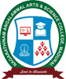

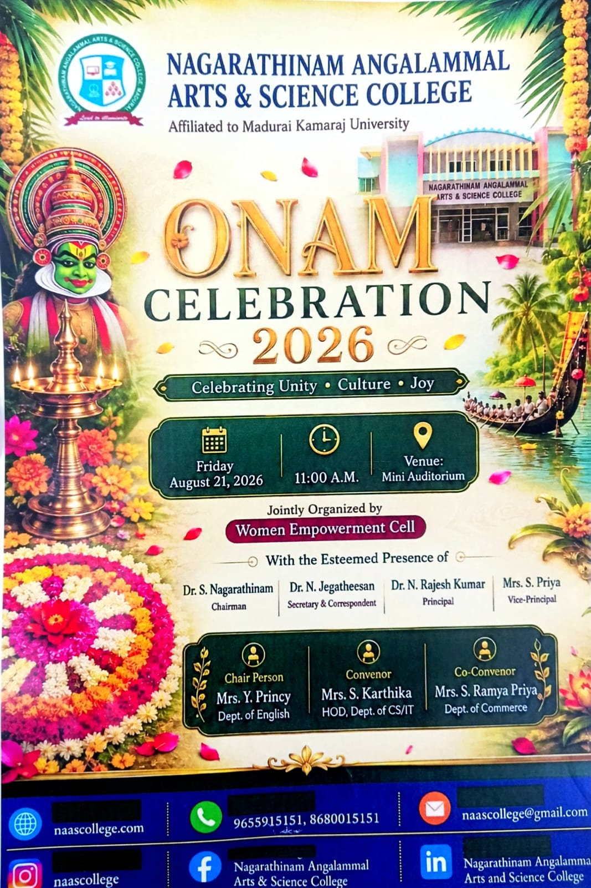

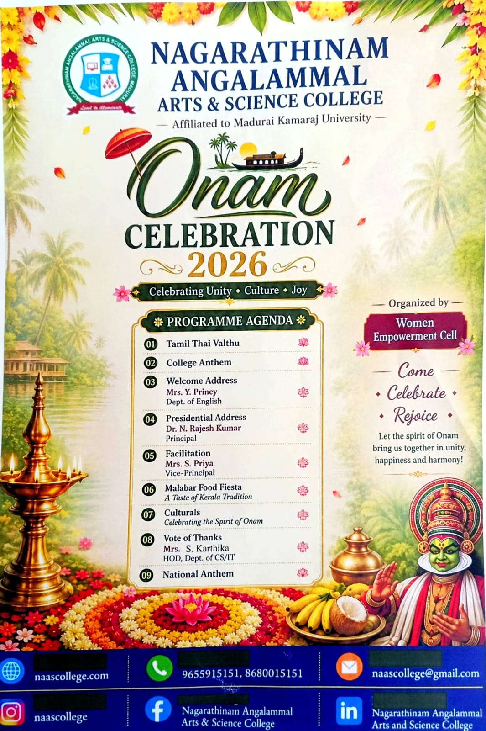

REPORT FOR ONAM CELEBRATION-2025

Name of the Institution: Nagarathinam Angalammal Arts & Science College
Event: Onam Celebration 2026
Organized by: Women Empowerment Cell

Introduction
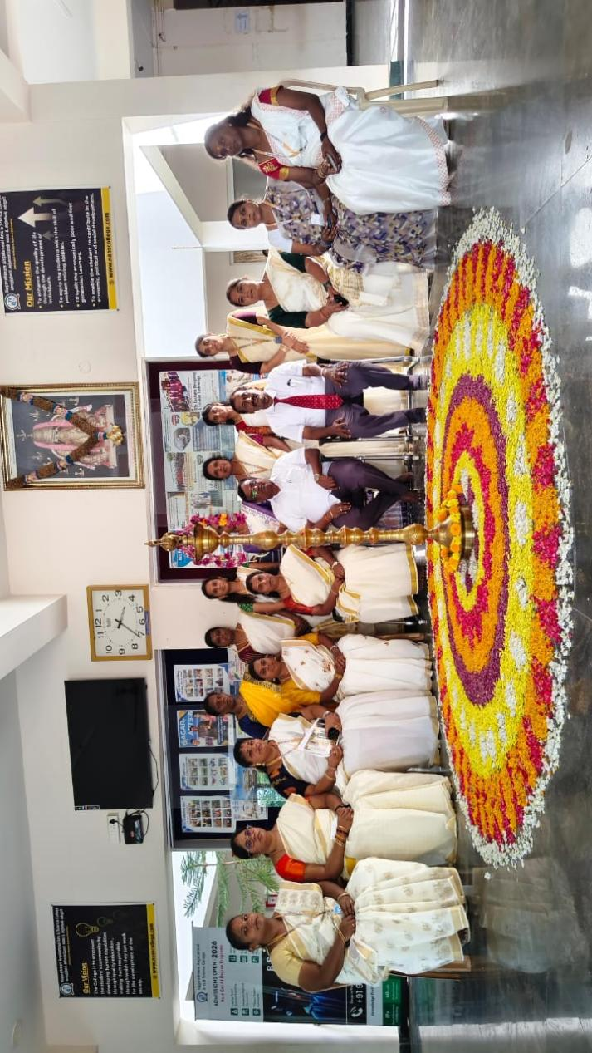
Nagarathinam Angalammal Arts & Science College organized Onam Celebration 2026 with the theme “Celebrating Unity • Culture • Joy.” The programme was organized by the Women Empowerment Cell to celebrate the rich cultural traditions of Kerala and to promote unity, harmony, cultural awareness and joyful participation among the students and staff of the institution.
The celebration provided an opportunity for the members of the college community to learn about and experience the cultural heritage associated with Onam. The programme featured traditional elements, cultural performances and a Malabar food fiesta showcasing the flavours and traditions of Kerala.

Programme Proceedings
The programme commenced with the Tamil Thai Valthu, followed by the College Anthem. The gathering was then formally welcomed by Mrs. Y. Princy, Chair Person Women Empowerment Cell, who delivered the Welcome Address.

WELCOME ADDRESS
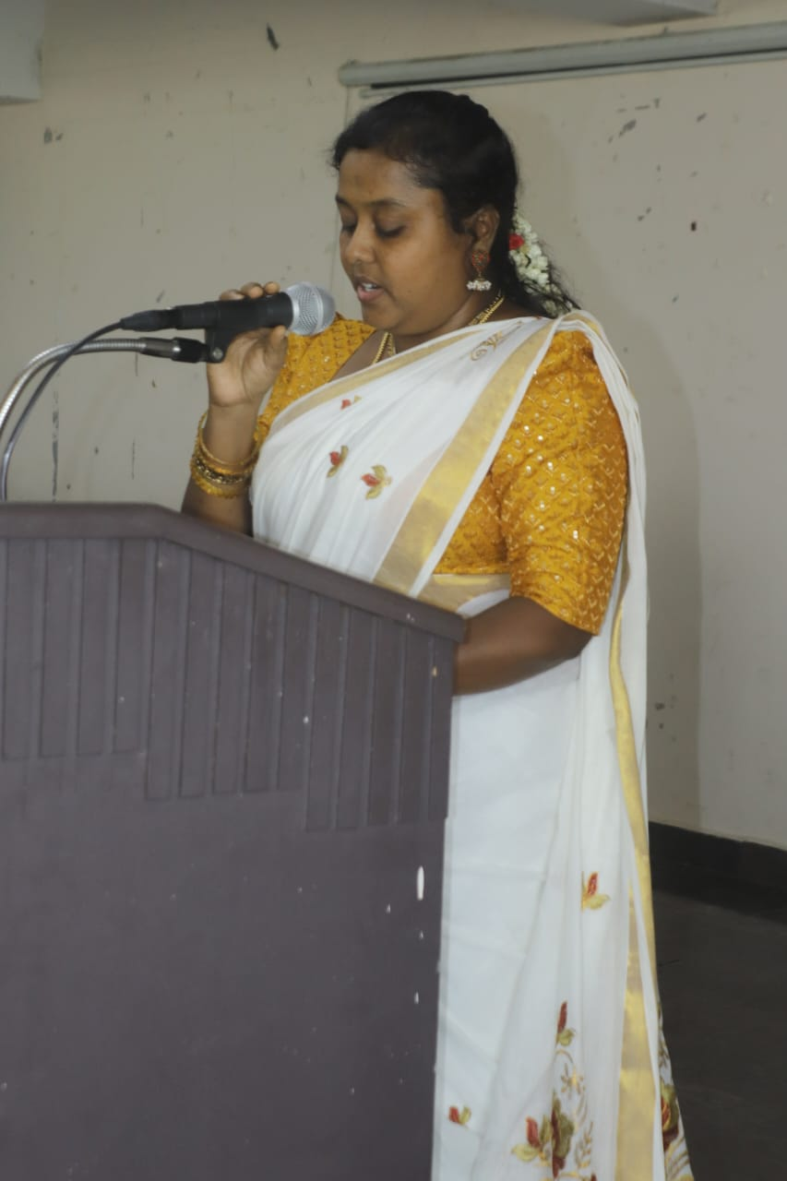
The Presidential Address was delivered by Dr. N. Rajesh Kumar, Principal, who highlighted the importance of celebrating cultural festivals in educational institutions. His address emphasized unity, cultural appreciation and the need to preserve traditional values among the younger generation.
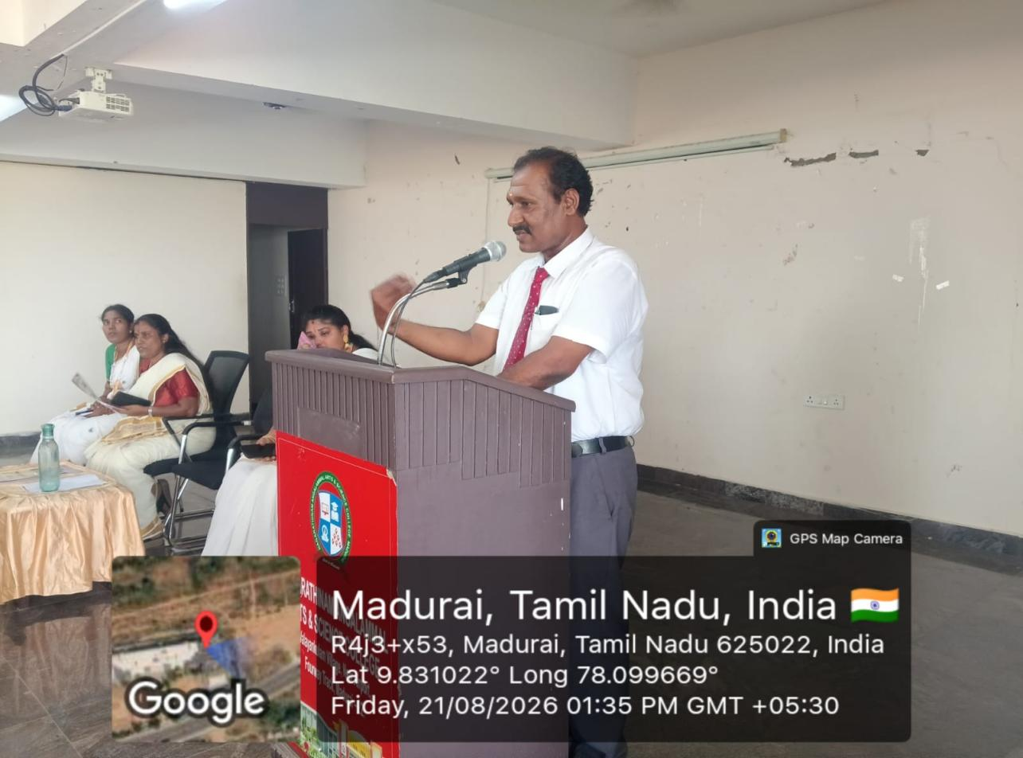
FELICITATION ADDRESS
The programme also included a Felicitation by Mrs. S. Priya, Vice-Principal. Her participation added significance to the celebration and encouraged the organizers and participants.
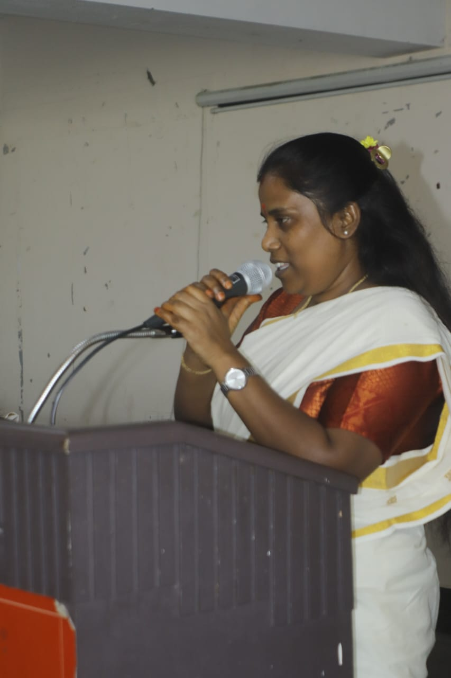
One of the major attractions of the celebration was the Malabar Food Fiesta – “A Taste of Kerala Tradition.” The food fiesta provided an opportunity for participants to experience traditional Malabar cuisine and appreciate the culinary heritage of Kerala.
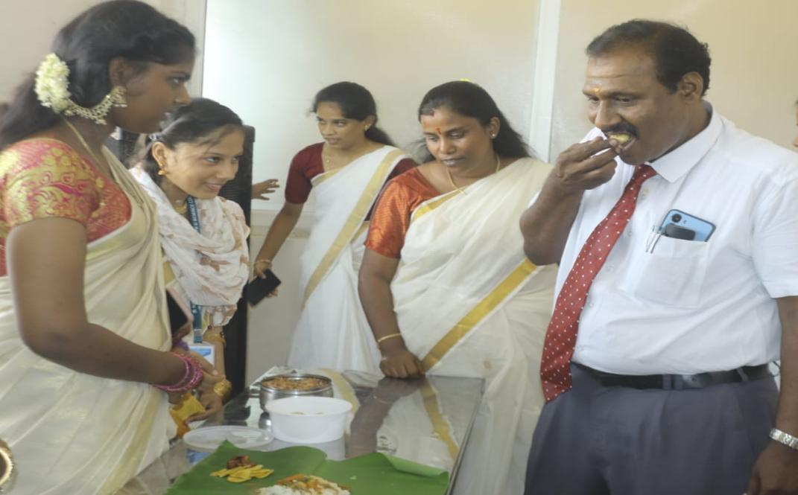
The Cultural Programme – “Celebrating the Spirit of Onam” was another important part of the event. The cultural activities created an atmosphere of enthusiasm and togetherness and enabled students to showcase their talents while celebrating the spirit of Onam.
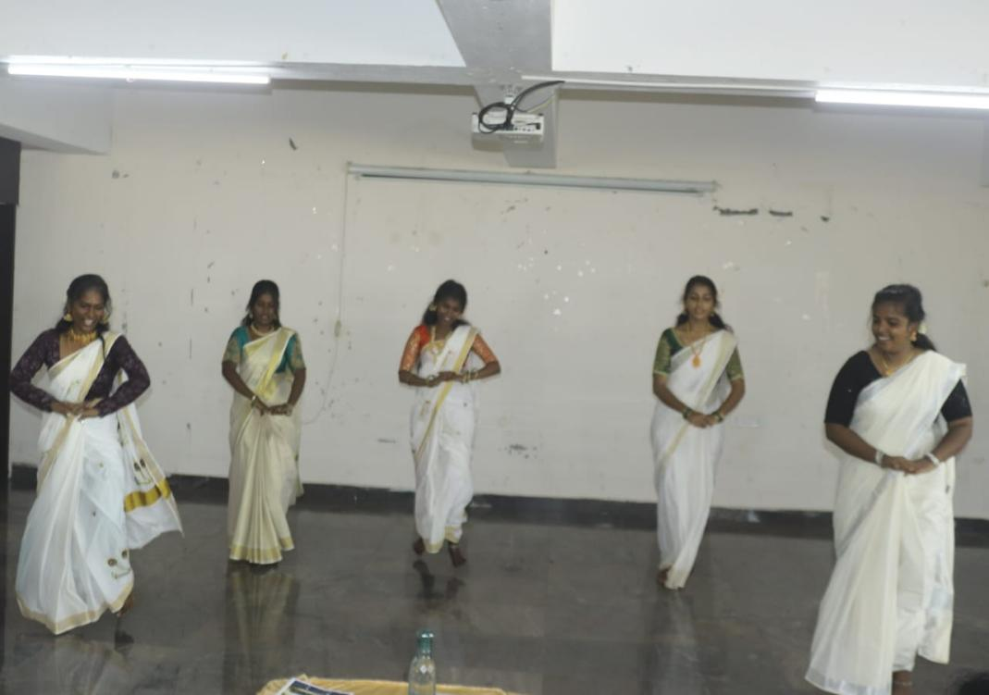
PRIZE DISTRIBUTION
The ceremony created a positive and motivating atmosphere among the students. It encouraged healthy competition, built confidence, and inspired students to actively participate in various activities.The Prize Distribution Ceremony was a memorable occasion that celebrated student excellence and motivated everyone to strive for continuous improvement and success.
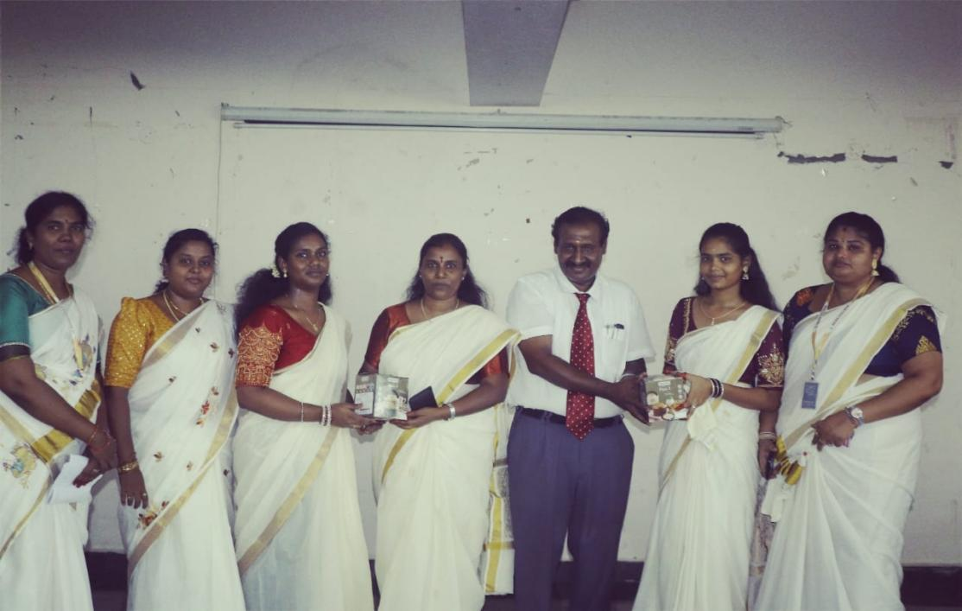
VOTE OF THANKS
The programme concluded with the Vote of Thanks delivered by Mrs. S. Karthika, HOD, Department of CS/IT, followed by the National Anthem.

Objectives of the Celebration
- To celebrate the cultural significance of Onam.
- To promote unity, harmony and togetherness among students and staff.
- To create awareness about Kerala's traditional culture and heritage.
- To encourage students to participate in cultural activities.
- To provide a platform for students to exhibit their talents.
- To promote appreciation of traditional food, customs and cultural practices.

Outcome of the Programme
The Onam Celebration 2026 was a meaningful and joyful cultural event. It successfully brought students and staff together in an atmosphere of unity, happiness and harmony. The cultural performances and Malabar Food Fiesta helped participants understand and appreciate the traditions of Kerala. The programme also strengthened the spirit of inclusiveness and cultural exchange within the college community.

Conclusion
The Onam Celebration 2026 was successfully conducted under the auspices of the Women Empowerment Cell, Nagarathinam Angalammal Arts & Science College. The celebration reflected the values of unity, culture and joy and provided a memorable experience for all participants. The event demonstrated the institution's commitment to promoting cultural awareness, student participation and social harmony through meaningful celebrations.

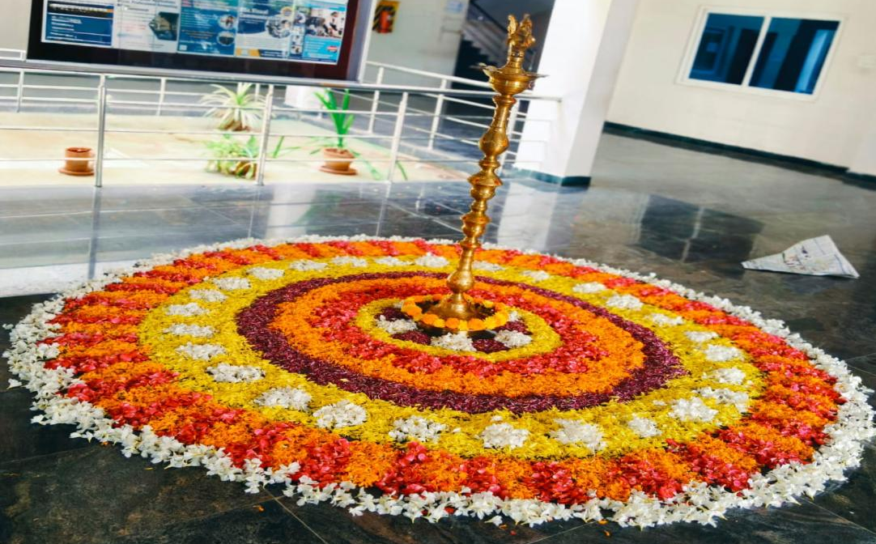

ATTENDANCE SHEET 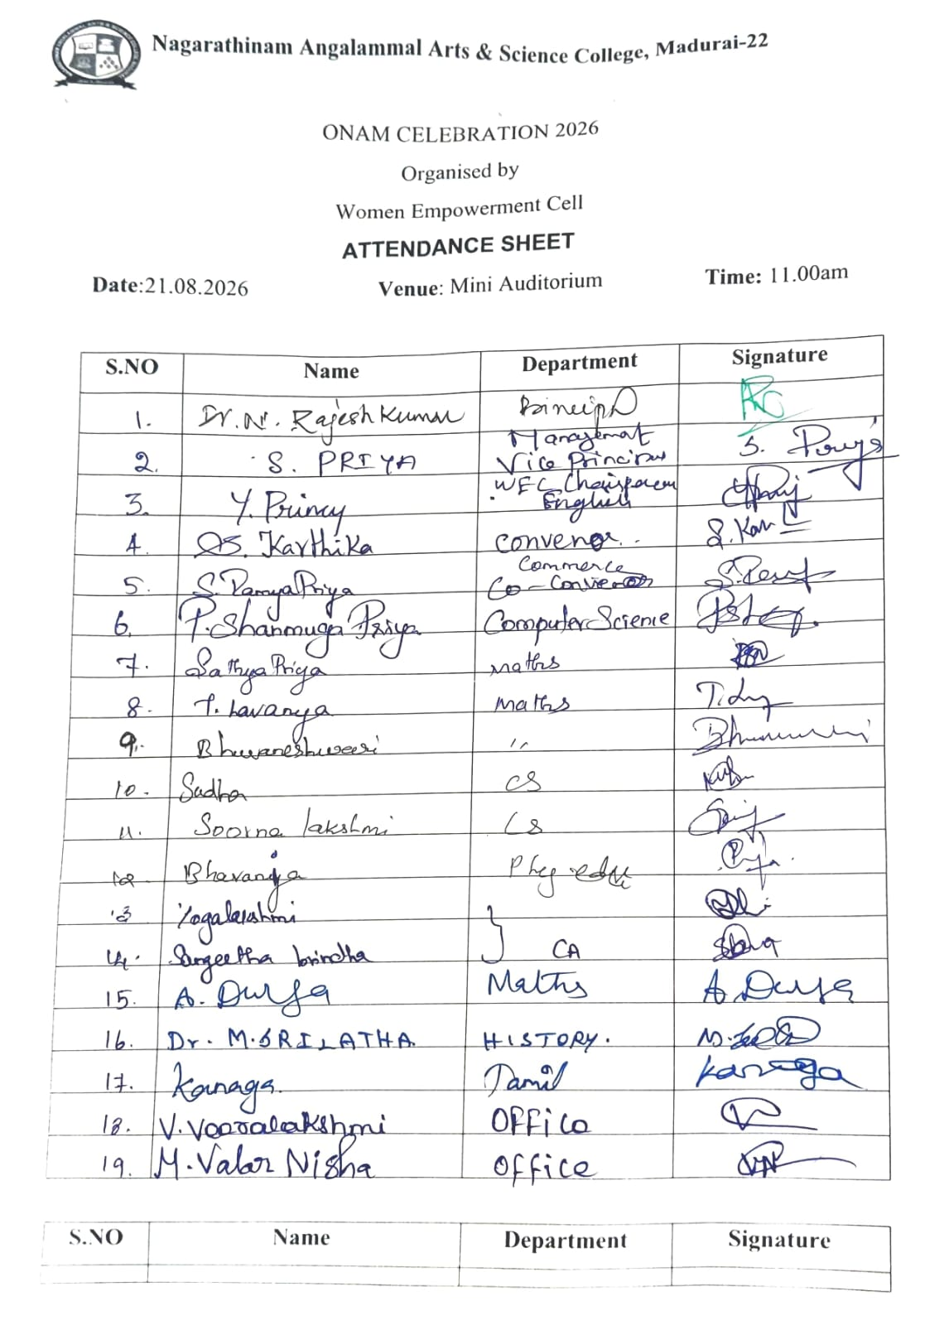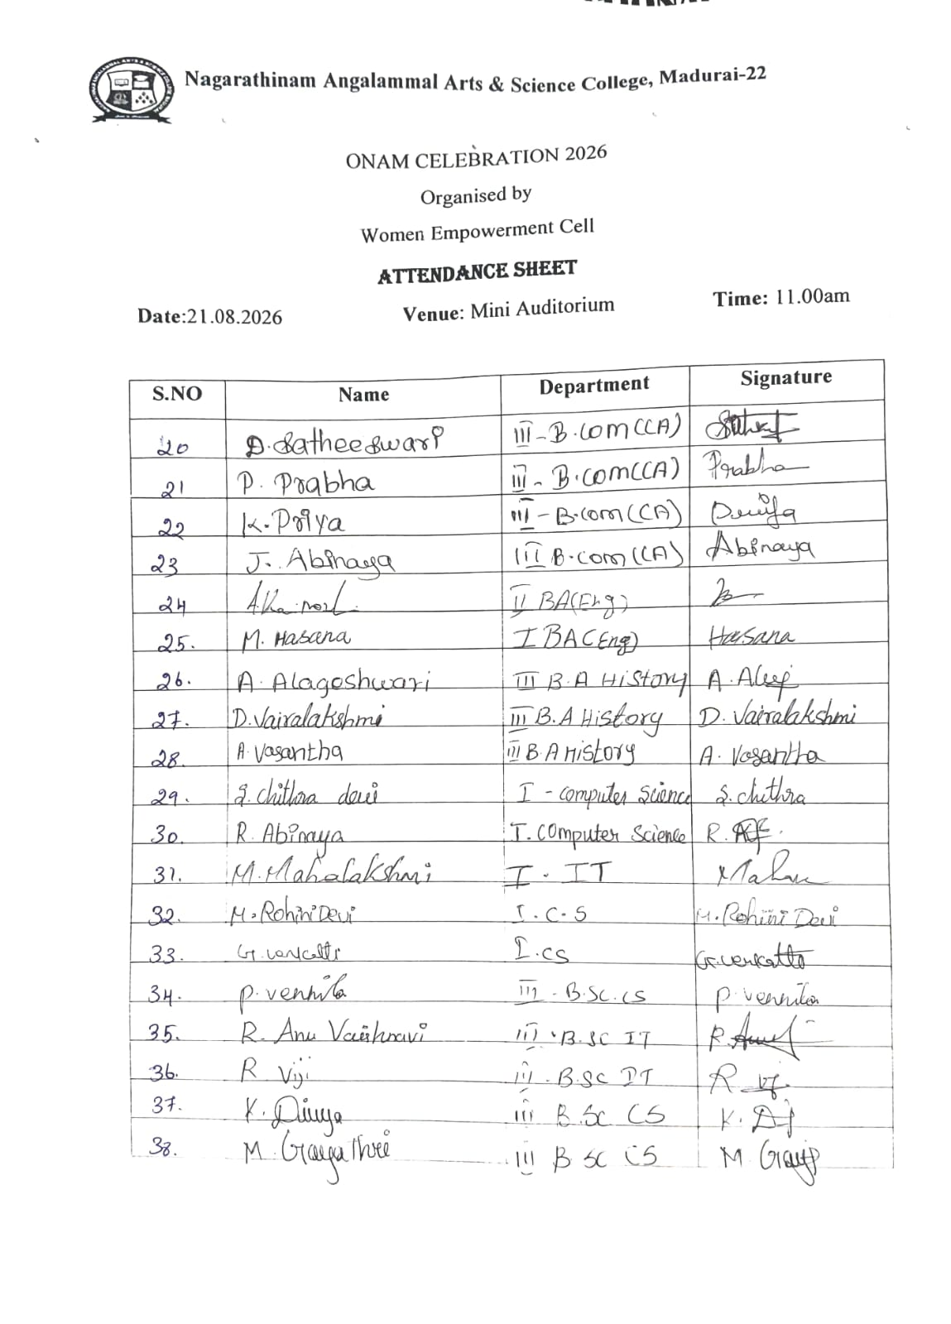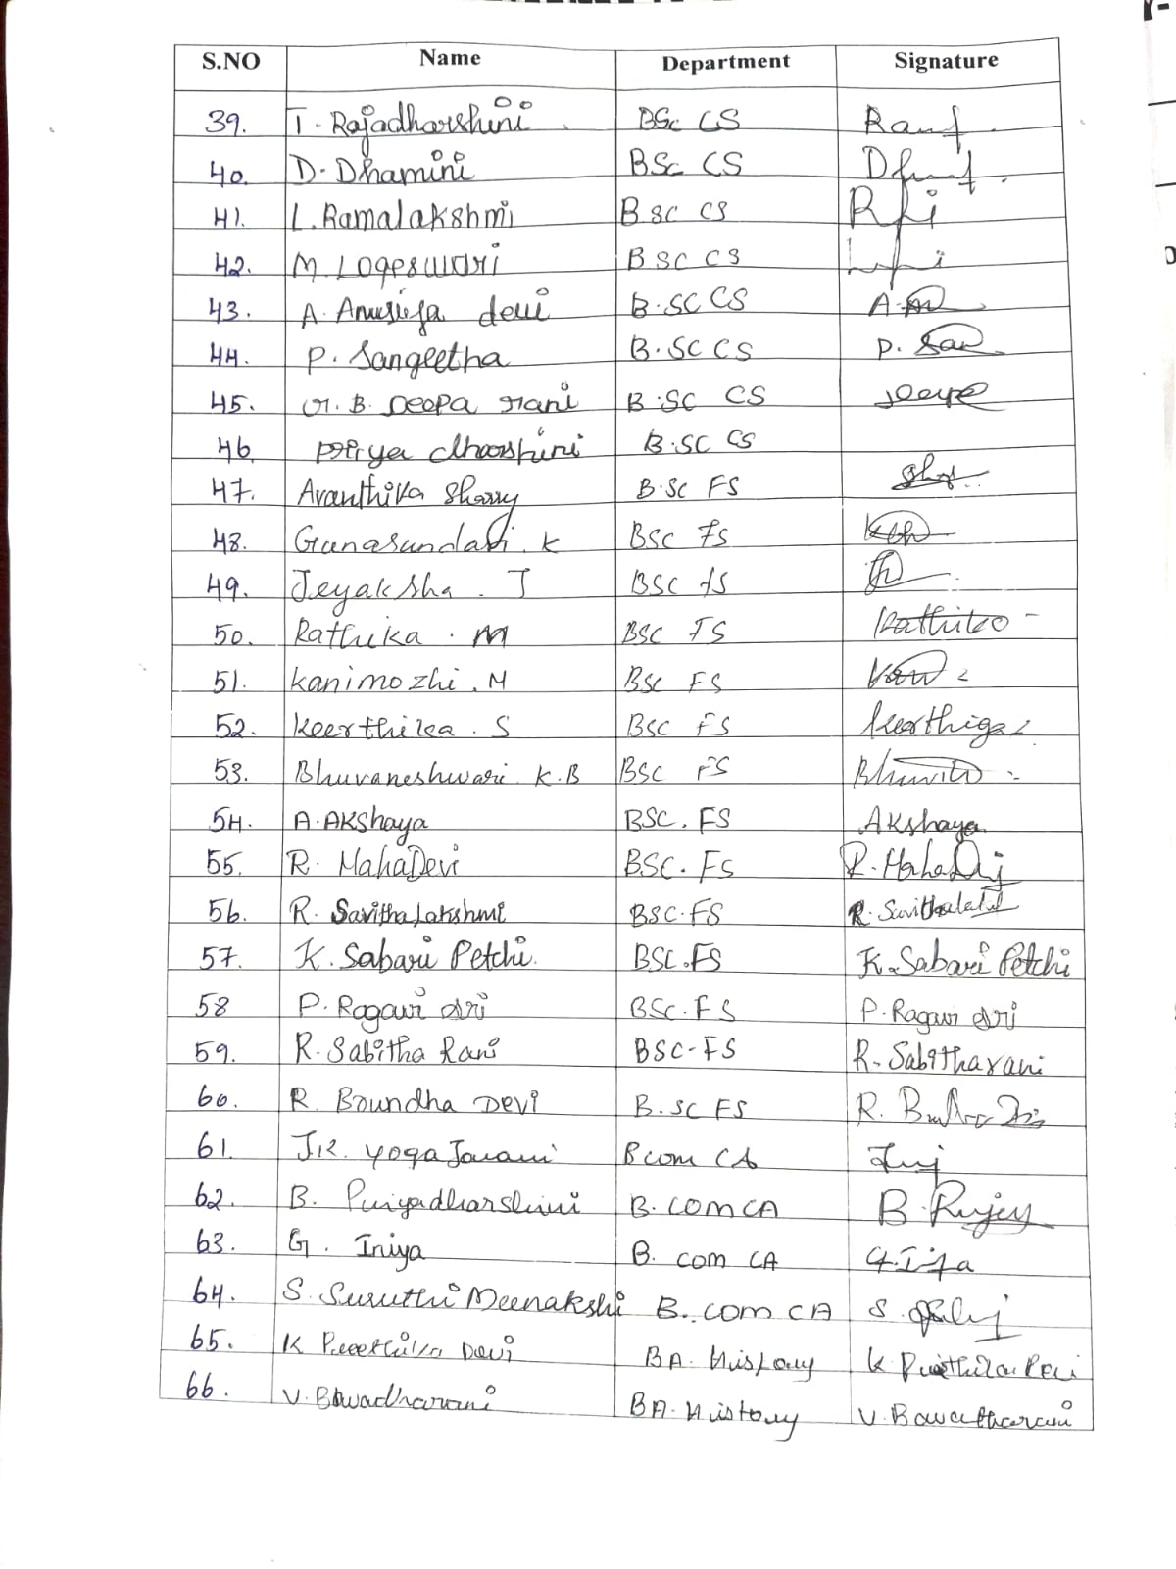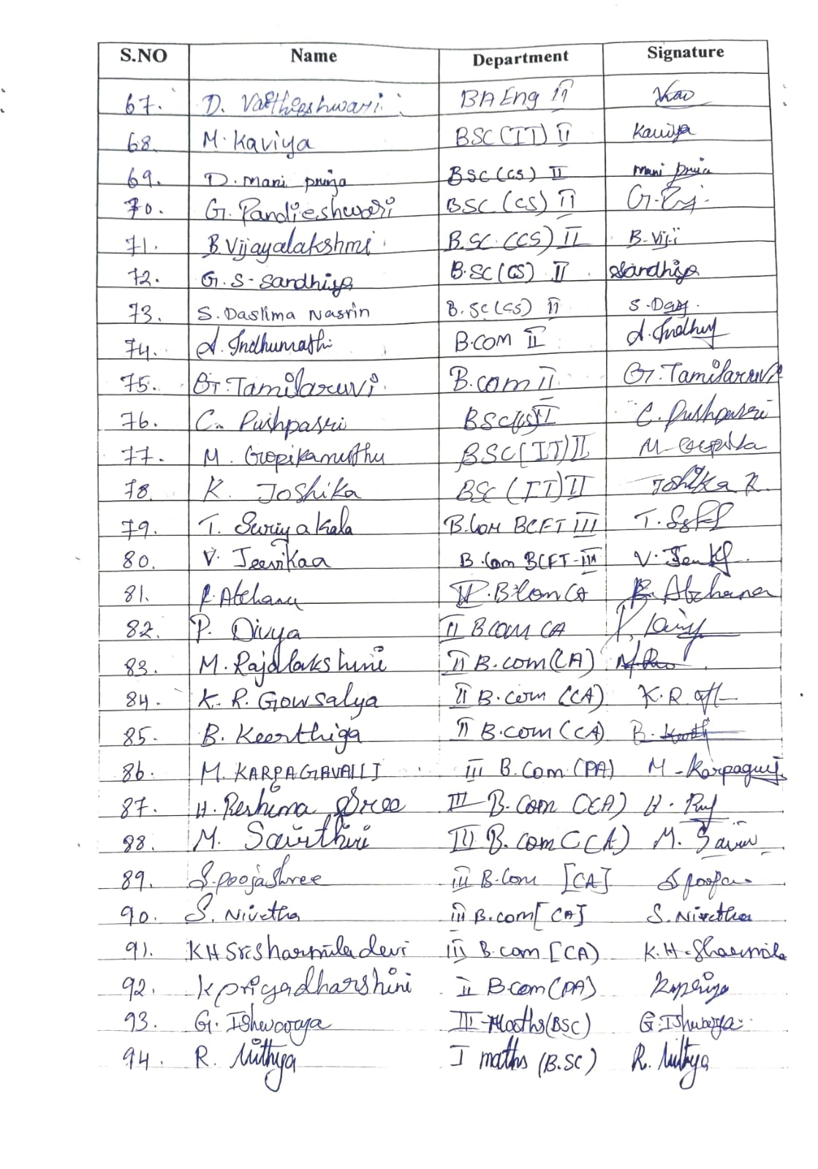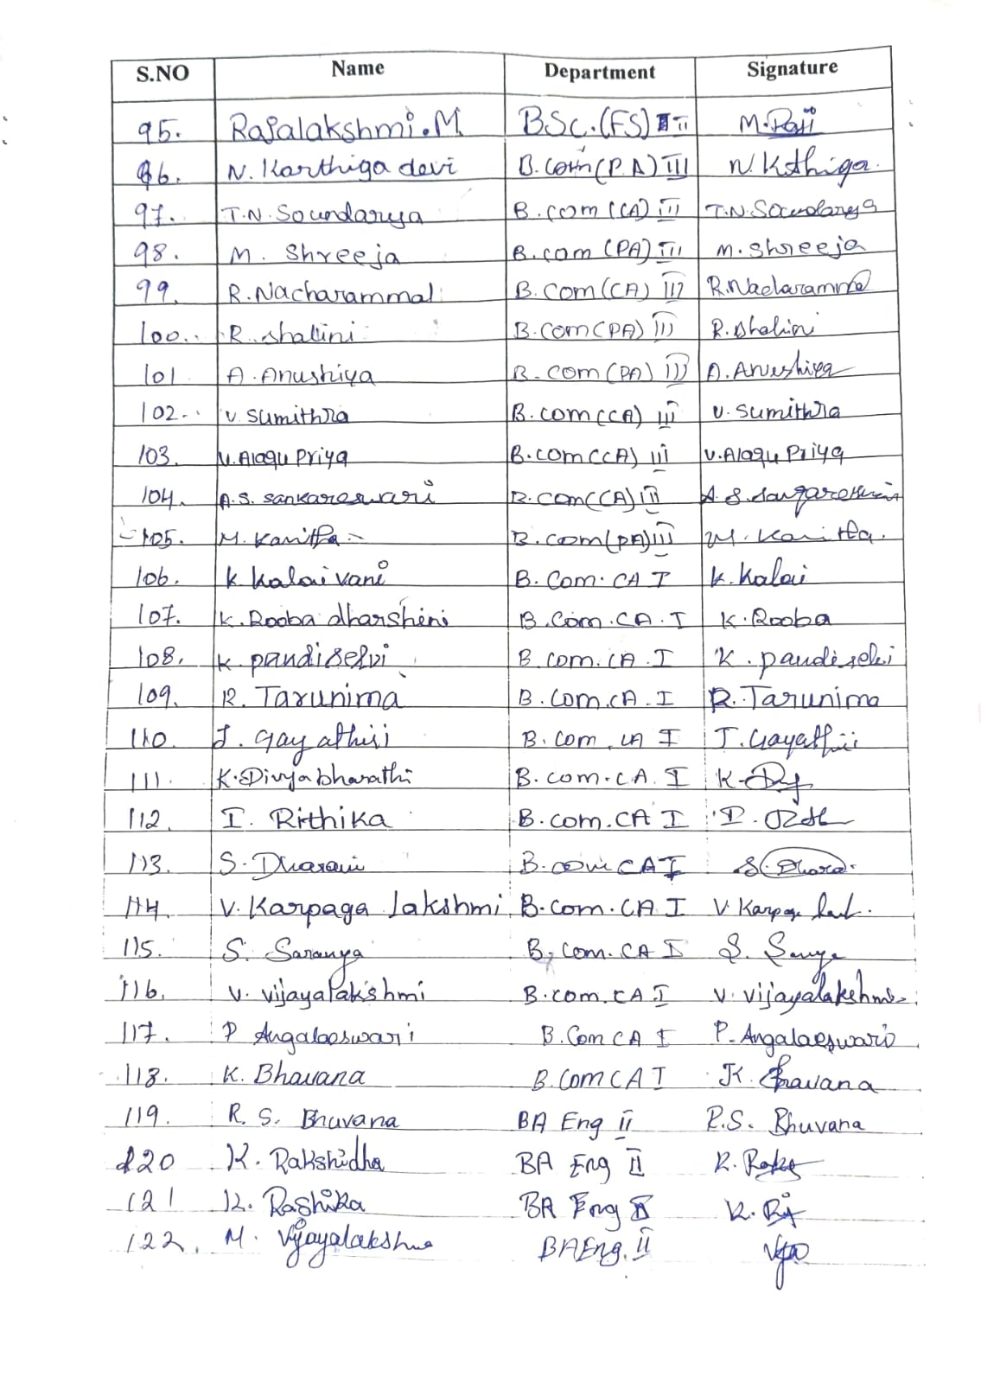

Chair Person (WEC) IQAC Co-Ordinator Principal

